ONE

One of the classic applications of Linear Programming is the diet problem. The Diet Problem in Linear Programming was one of the first optimization problems studied in the 1930s and 1940s. The main goal is to select a set of foods that meets certain daily nutritional requirements and preferences and additionally at minimum cost. Let´s consider the following list of foods with their nutritional profile to illustrate this application:

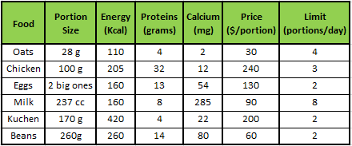

We wish to propose a diet containing at least 2,000 (Kcal), at least 55 grams of protein and 800 (mg) of calcium. In addition, to provide some variety in the diet, some limits are set for the daily portions of food. This information is required to find the diet that has the lowest cost associated with meeting the above requirements. To do this we define the following linear programming model:

**1.Decision Variables:** Select a set of foods to include in the daily diet.



1. **Objective Function:** Minimize the cost of the daily diet.



1. **Constrains:** Meets daily nutritional requirements and preferences.

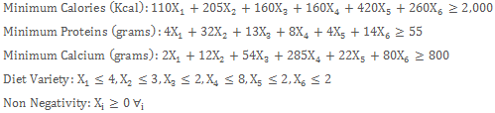

TWO

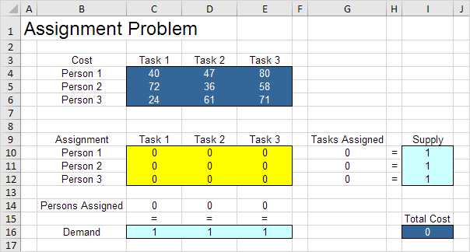

THREE

A corporation plans on building a maximum of 11 new stores in a large city.

They will build these stores in one of three sizes for each location. A convenience store (open 24 hours), standard store, and an expanded services store. The convenience store requires $4.125 million to build and 30 employees to operate. The standard store requires $8.25 million to build and 15 employees to operate. The expanded-services store requires

$12.375 million to build and 45 employees to operate. The corporation can dedicate $82.5 million in construction capital, and 300 employees to staff the stores. On the average, the convenience store nets $1.2 million annually, the standard store nets $2 million annually, and the expanded services store nets $2.6 million annually. How many of each should they build to maximize revenue?